Drone Assembly Manual

1. All components needed
   1. Kakute H7 Mini
   2. Tekko32 F4 Mini 50A ESC
   3. GPS
   4. TBS Crossfire Nano Receiver
   5. 4 Diatone Mamba Toka 1206 2450KV Motors
   6. 4 3-Inch Propellers
   7. IR-Lock
   8. LiDAR Lite v3
   9. 680µF electrolytic capacitor
   10. CAD airframe
   11. CAD battery mount
   12. CAD sensor mount
   13. CAD drone mount
2. Extra equipment
   1. 25ft 20 AWG Wires
   2. Soldering Kit
   3. 22 M3\*8 screws
   4. 4 M3\*16 screws
   5. M3 Allen key
   6. 24 M2\*4 screws
   7. M2 Allen key
   8. 4 rubber mounts for flight stack
   9. Electrical tape
3. Instructions
   1. Mounting
      1. Use 16 M2 screws to screw the 4 Diatone Mamba Toka 1206 2450KV Motors to the end of the 4 arms of the airframe as shown in Figure 1

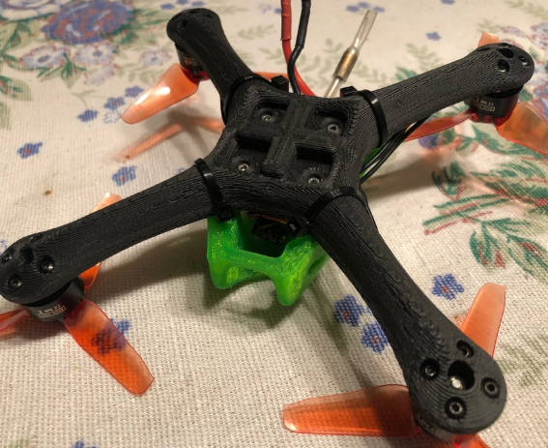

Figure 1: Bottom view of the airframe showing 16 M2\*4 screws used to attack the motors to the airframe and 4 M3\*8 screws used to attach the Tekko32 F4 Mini 50A ESC to the airframe (ignore green CAD).

* + 1. Use 4 M3 screws to screw the Tekko32 F4 Mini 50A ESC onto the midde of the airframe as shown in Figure 1.
    2. Place the Kakute H7 Mini flight controller onto the top of the Tekko32 F4 Mini 50A ESC using the 4 rubber mounts (used for dampening) as shown in Figure 2

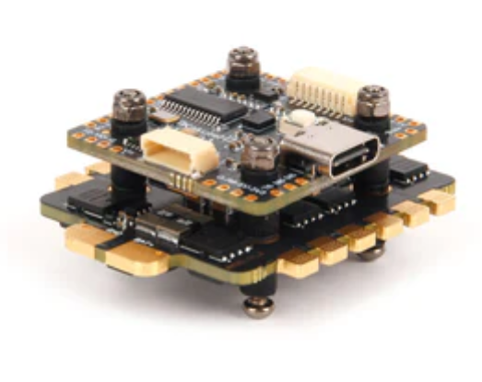

Figure 2: Flight stack of the Kakute H7 Mini on top of the Tekko32 F4 Mini 50A ESC.

* + 1. Then place the CAD battery mount on top of the flight controller using 4 M3\*16 screws and 3 M3\*8 screws.
  1. Soldering Electrical Components Together
     1. Figure 3 shows connections for the flight controller to the Tekko32 F4 Mini 50A ESC, GPS, TBS Crossfire Nano Receiver, 4 Diatone Mamba Toka 1206 2450KV Motors, IR-Lock, LiDAR Lite v3, which requires soldering.

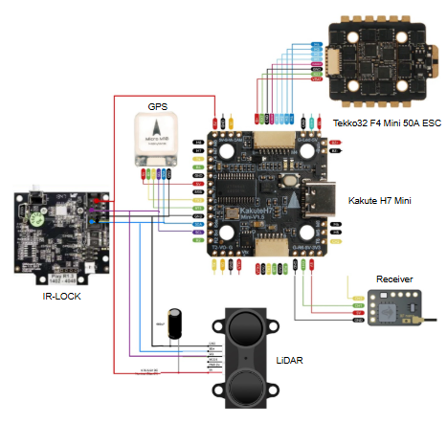

Figure 3: Connection of electrical components to the Kakute H7 Mini.

* + 1. Note: Solder the 680µF electrolytic capacitor as shown in Figure 4.

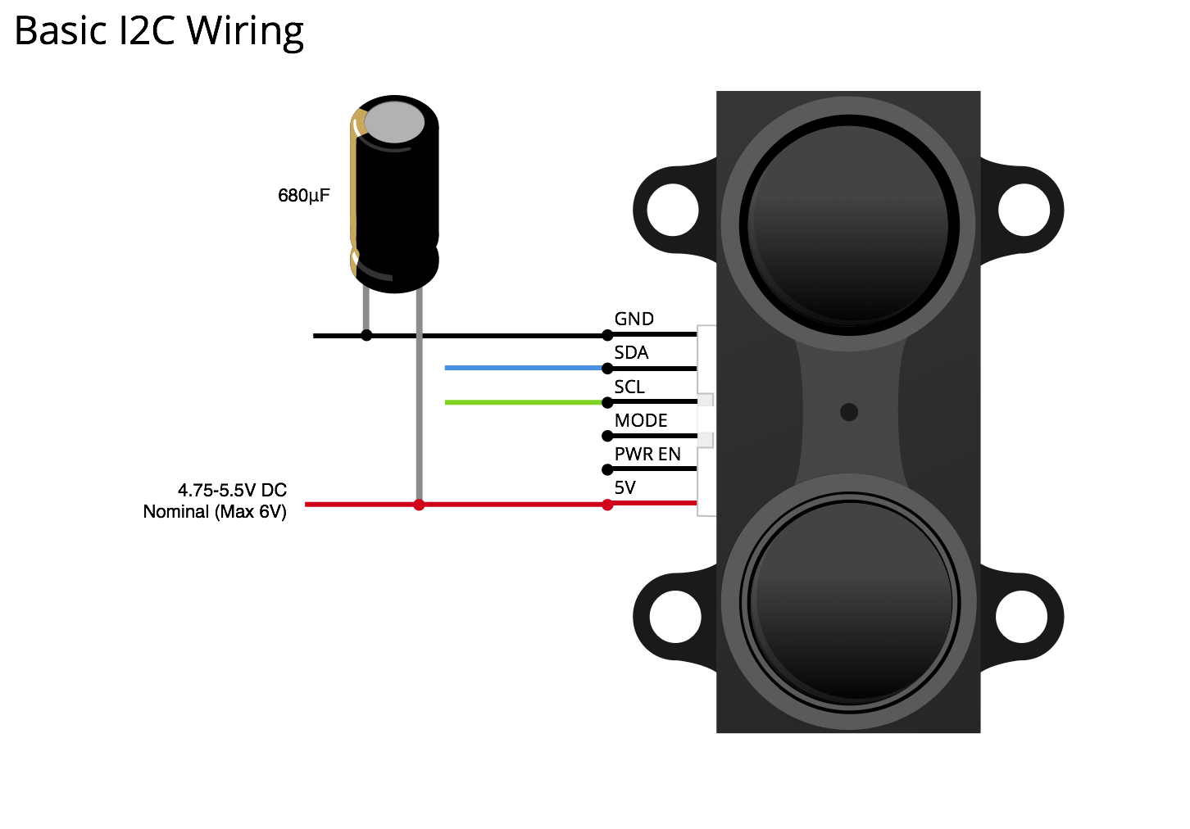

Figure 4: LiDAR Lite v3 configuration to activate 12C connection to Kakute H7 Mini.

* + 1. The 4 Diatone Mamba Toka 1206 2450KV Motors are soldered to the Tekko32 F4 Mini 50A ESC as shown in Figure 5.

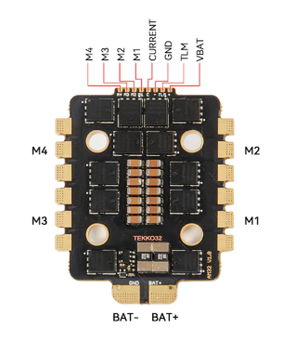

Figur 5: Tekko32 F4 Mini 50A ESC connected to 4 motors: M1, M2, M3, and M4 three wire configuration.

* 1. Final Touches
     1. Attach the LiDAR Lite v3 and the IR-Lock to the CAD sensor mount using 7 M3\*8 screws as shown in Figure 6.

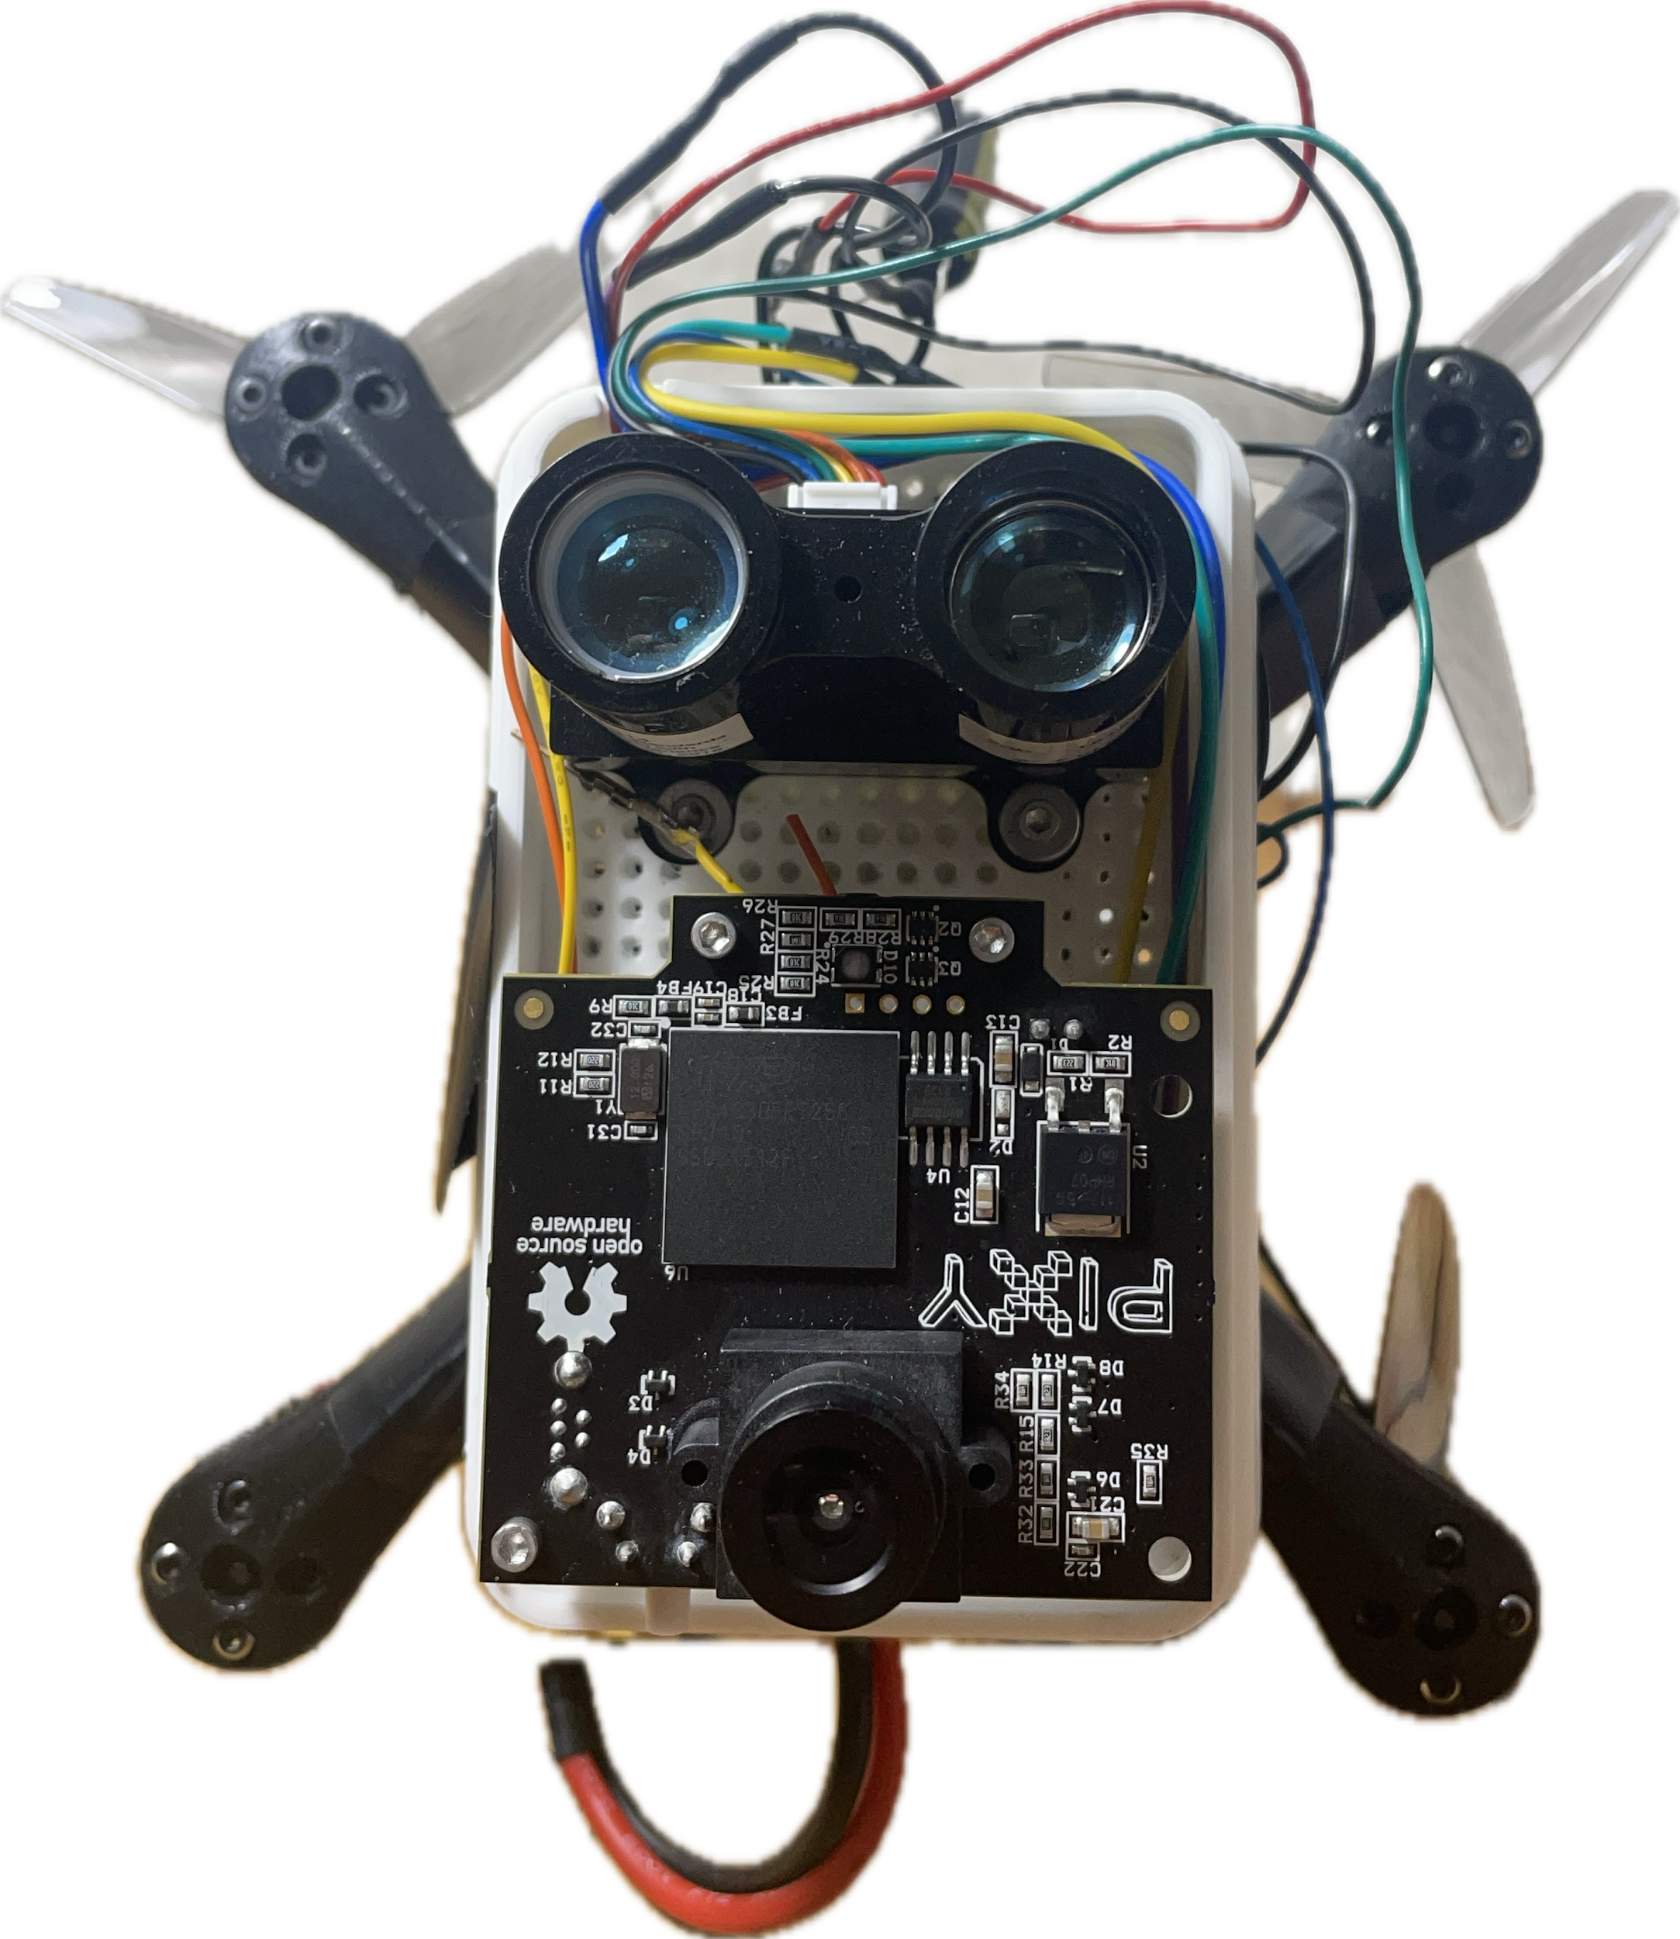

Figure 6: Precision landing Module showing the LiDAR and IR-Lock mounted onto the CAD sensor mount using 7 M3\*8 screws, 4 for the LiDAR and 3 for the IR-Lock.

* + 1. Attach the CAD drone mount using 4 M3\*8 screws on the side as shown in Figure 7.

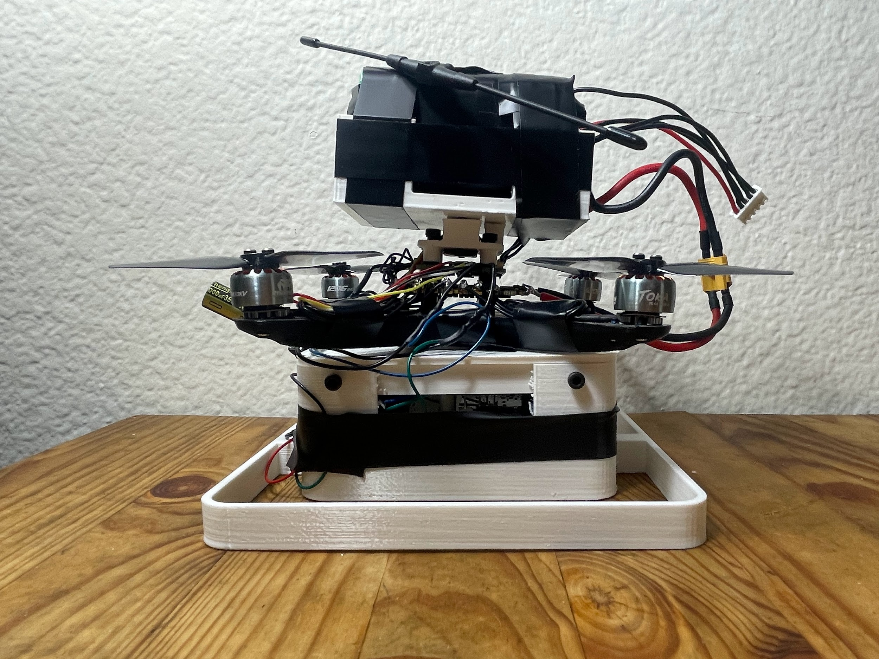

Figure 7: 4 M3\*8 screws used to attach the CAD drone mount to the CAD sensor mount.

* + 1. Attach the 4 lithium-ion batteries to the CAD battery mount using electrical tape as shown in Figure 8.

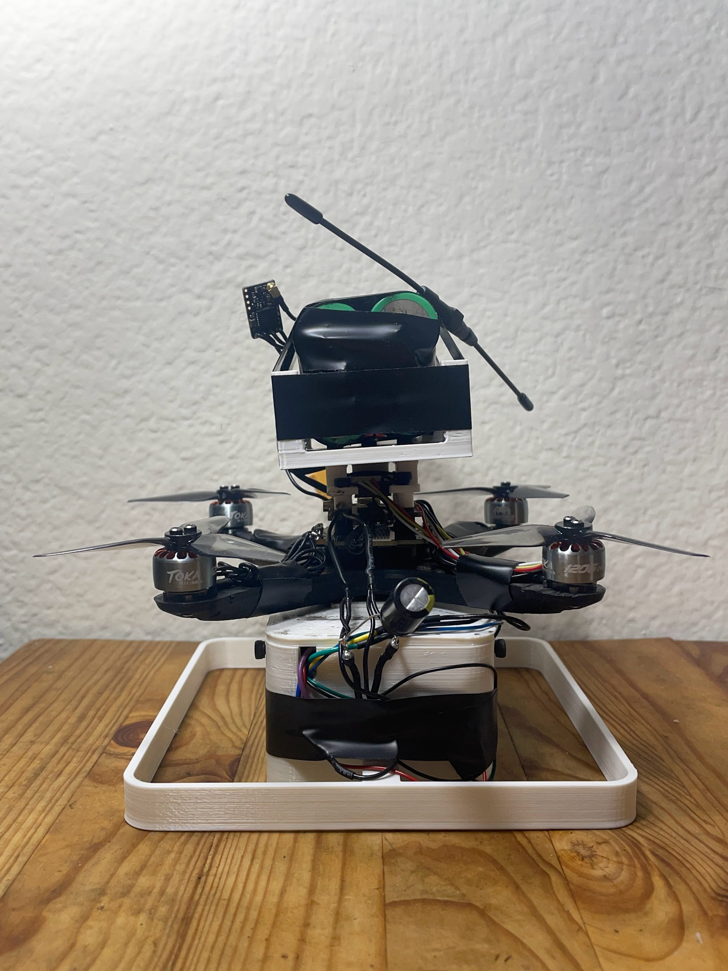

Figure 8: 4 Lithium-ion batteries mounted on the CAD battery mount using electrical tape.

* + 1. Attach the 4 3-inch propellers to the top of the motor using 8 M2\*4 screws.
    2. Tape down any free-hanging wires to avoid hitting the propellers

1. Software
   1. Flash a compatible version of ArduPilot onto Kakute H7 Mini by following these instructions: <https://ardupilot.org/copter/docs/common-loading-firmware-onto-chibios-only-boards.html#common-loading-firmware-onto-chibios-only-boards>
   2. Use the following firmware version: v1.5: KakuteH7Mini (Supported in master/latest FW or 4.6.0 & later).
   3. Install Mission Planner onto a laptop.
   4. Connect the drone via a USB-C cable from the Kakute H7 Mini to the Laptop.
   5. Go through the setup and configuration.
2. Result shown in Figure 9.



Figure 9: Final result of the drone.